

# Practical – 1

**Aim: Introduction to CISCO Packet Tracer software.**

1. Use different types of devices like pc, switches, cables, pc with wireless card.
2. Create basic topologies and assign IP address, subnet mask, DNS, gateway IP address.
3. Test connectivity with ping command.

## 1.1 Introduction to Packet Tracer

**What is Packet Tracer?**

Packet Tracer is a protocol simulator developed by Dennis Frezzo and his team at Cisco Systems. Packet Tracer (PT) is a powerful and dynamic tool that displays the various protocols used in networking, in either Real Time or Simulation mode. This includes layer 2 protocols such as Ethernet and PPP, layer 3 protocols such as IP, ICMP, and ARP, and layer 4 protocols such as TCP and UDP. Routing protocols can also be traced.

**Purpose:** The purpose of this lab is to become familiar with the Packet Tracer interface. Learn how to use existing topologies and build your own.

**Requisite knowledge:** This lab assumes some understanding of the Ethernet protocol. At this point we have not discussed other protocols, but will use Packet Tracer in later labs to discuss those as well.

**Version:** This lab is based on Packet Tracer 4.0 ,8.1.

## Introduction to the Packet Tracer Interface using a Hub Topology

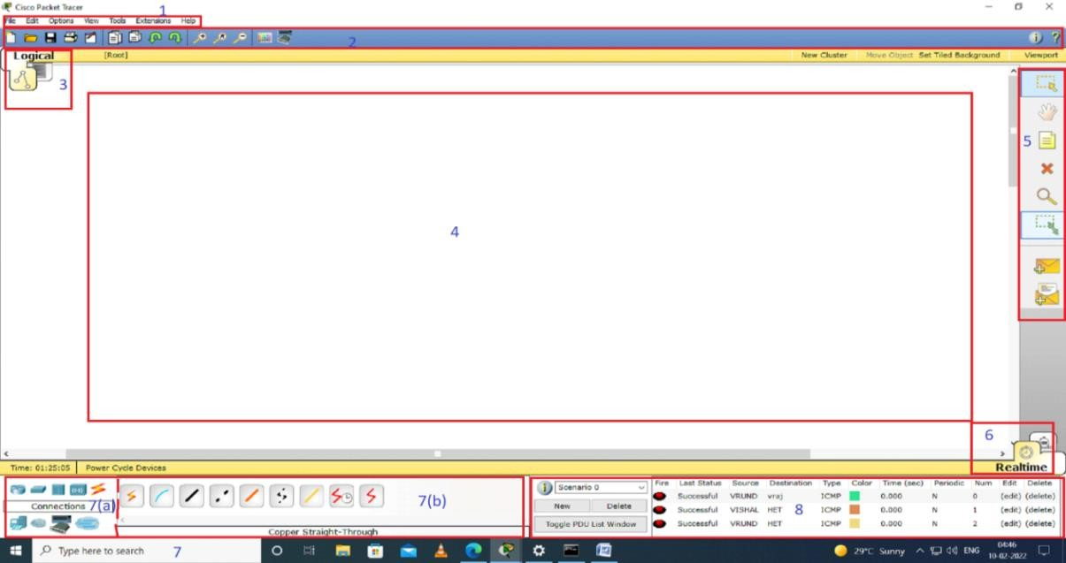

1. **Enrolment Number: 12002040701068** **Name: Hussain Adenwawala**



## The components of the Pocket Tracer interface are as follows:

* + 1) Menu bar – This is a common menu found in all software applications; it is used to open, save, print, change preferences, and so on.
  + 2) Main toolbar – This bar provides shortcut icons to menu options that are commonly accessed, such as open, save, zoom, undo, and redo, and on the right-hand side is an icon for entering network information for the current network.
  + 3) Logical/Physical workspace tabs – These tabs allow you to toggle between the Logical and Physical work areas.
  + 4) Workspace – This is the area where topologies are created and simulations are displayed.
  + 5) Common tools bar – This toolbar provides controls for manipulating topologies, such as select, move layout, place note, delete, inspect, resize shape, and add simple/complex PDU.
  + 6) Realtime/Simulation tabs – These tabs are used to toggle between the real and simulation modes. Buttons are also provided to control the time, and to capture the packets.
  + 7) Network component box – This component contains all of the network and end devices available with Packet Tracer, and is further divided into two areas:
* 7a) Device-type selection box – This area contains device categories
* 7b) Device-specific selection box – When a device category is selected, this selection box displays the different device models within that category
  + 8) User-created packet box – Users can create highly-customized packets to test their topology from this area, and the results are displayed as a list.
* The network devices consists of End devices, Components, Connections, Miscellaneous, Multiuser connection, routers, switches, hubs, WAN emulator, security. (Network component box )
* **END DEVICES:**

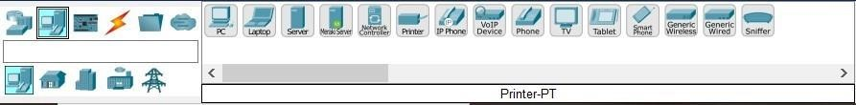

* End devices are either the source or destination of data transmitted over the network, to distinguish one end device to other each end device has an address.

1. **Enrolment Number: 12002040701068** **Name: Hussain Adenwala**



* **COMPONENTS:**



* It consists of Smart things, which is a physical objects that connect to the registration server or home gateway through a network interface.
* They also consists of microcontroller(MCU-PT), and single boarded computers(SBC-PT).
* **CONNECTIONS:**



* To connect devices in cisco packet tracer the different types of connection cables are used, they consist of console, copper cross over, copper straight through, fiber, coaxial, serial, USB.
* **MISCELLANEOUS:**



* It consists of 2 port WAN interface cards (WICs), Series Integrated Service Routers with cisco IOS, along with wireless laptop and wireless PC.
* **MULTI-USER CONNECTIONS:**



* The multiple user feature allows multiple point to point connections between multiple instances of packet tracer, it enables multiple networks on different computer to interact.
* **ROUTERS:**

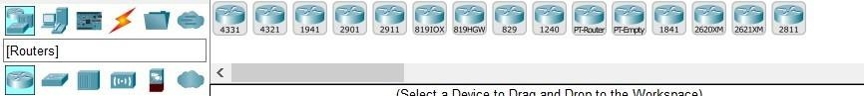

* A router is a networking device that forwards data packets between computer networks.
* It performs traffic directing function on internet, it basically consists of WIC modules or network modules.

1. **Enrolment Number: 12002040701068** **Name: Hussain Adenwala**



* **SWITCHES:**

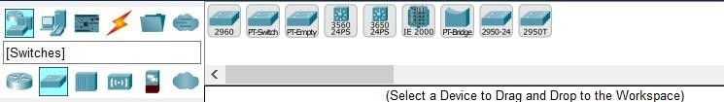

* Switch allows to set address on interface level.
* IP address assigned on interface is used to manage that particular interface.
* Cisco Packet Tracer offer two types of switches :

1. fixed configuration
2. modular configuration

* It allows to share information and talk to switch enabled connected devices.
* **HUBS:**

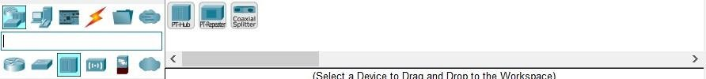

* A hub is basically a multiport repeater. A hub connects multiple wires coming from different branches, for example, the connector in star topology which connects different stations.
* Hubs cannot filter data, so data packets are sent to all connected devices.
* The collision domain of all hosts connected through Hub remains one.
* **WIRELESS DEVICES:**

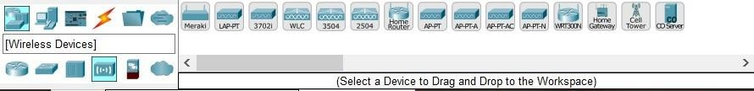

* It combines the mobility of wireless with performance of wired network, offering performance increase networks.
* It consist of WLC, Accesspoint, cell tower.
* **SECURITY:**

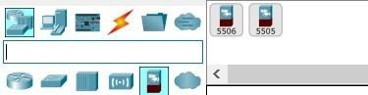

* It is an activity designed to protect the usability and integrity of your network and data, it includes both hardware and software tech.
* Provide powerful and more firewall and inspection capabilities.
* It targets variety of threats and stops them from entering or spreading in the system.
* Its types ARE 5505, 5506-X.

1. **Enrolment Number: 12002040701068** **Name: Hussain Adenwala**



* **WAN COMMUNICATION:**

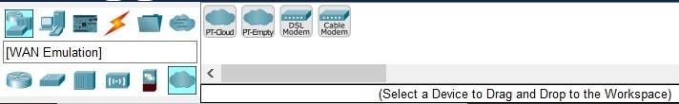

* It is a collection of local area networks (LANS), or other networks that communicate with one another.
* WAN router, also known as edge router or border router is a device that routes data packets between WAN locations.

1. **Enrolment Number: 12002040701068** **Name: Hussain Adenwala**



**CREATING TOPOLOGIES:**

* Taking 4 end devices.

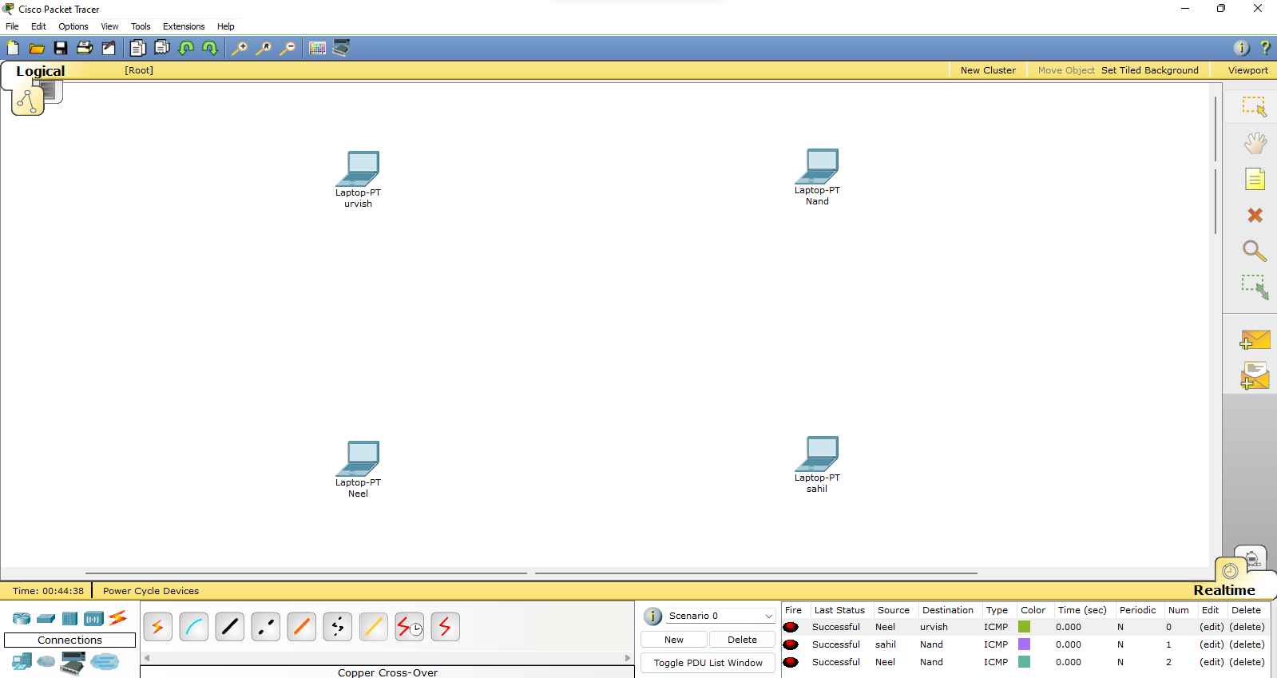

* Connect devices with switches with copper straight through connection.
* Connecting the switches with the copper cross over connection.

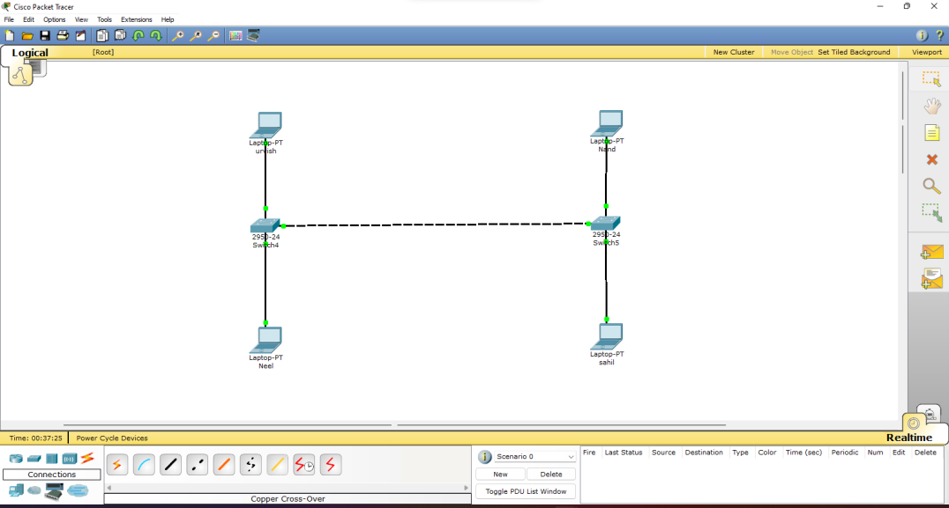

* **ASSIGNING IP ADDRESS AND SUBNET MASK:**
* Double click on the device -> Desktop -> IP Configuration.

1. **Enrolment Number: 12002040701068** **Name: Hussain Adenwala**



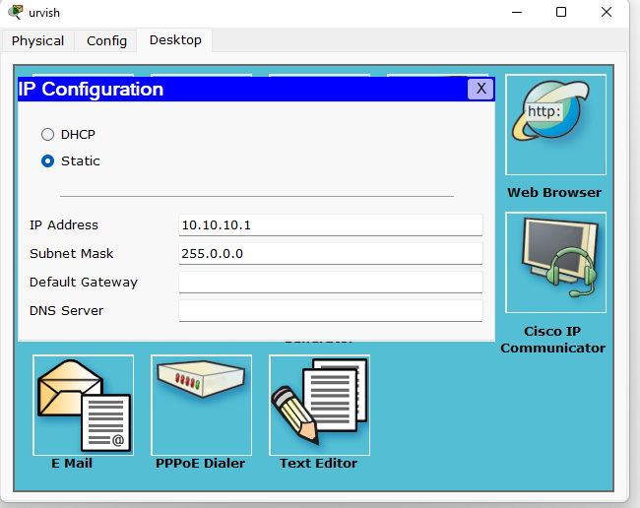

* **TEST PING COMMAND:**
* Syntax: ping <IP address>.

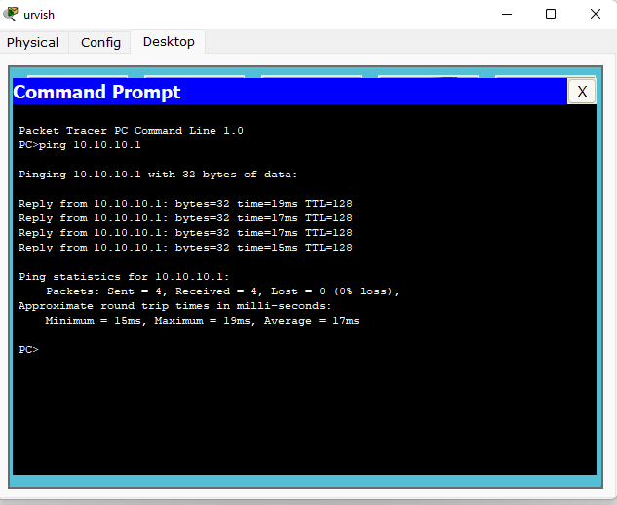

* After ping command when the envelope is send the message is received successfully by other device.

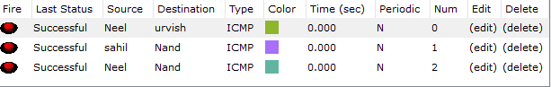

1. **Enrolment Number: 12002040701068** **Name: Hussain Adenwala**